CENG 317
HARDWARE PRODUCTION TECHNOLOGY

Build Instruction &
Hardware Report
Ambient Light Sensing System for Raspberry Pi
Using VEML7700 ambient light sensor

Author: Chau Vi Cuong Nguyen
Date: August 14, 2026

Table of Contents
1.0 Introduce the Broadcom development platform and existing functionality 2
2.0 Added functionality 3
2.1. Sensor/Effector purchase 4
2.2 PCB design and soldering 5
2.3 Case design and assembly 10
2.4 Firmware development and use 11
3.0 Testing and Results 14
4.0 References 15
5.0 Appendices 17

1.0 Introduce the Broadcom development platform and existing functionality
The Raspberry Pi is a single-board computer developed by the Raspberry Pi Foundation, built around a Broadcom BCM2711 system-on-chip (SoC) for the Raspberry Pi 4 Model B, or BCM2835/BCM2837 for earlier models. The platform features a 64-bit ARM Cortex-A72 processor (Raspberry Pi 4), VideoCore VI GPU, and a variety of onboard connectivity options including HDMI, USB 3.0, Gigabit Ethernet, and 802.11ac Wi-Fi. The 40-pin GPIO (General Purpose Input/Output) header provides access to 28 programmable I/O pins, I2C, SPI, UART, PWM, and GPIO functionality, making it a versatile platform for embedded system development.
The Broadcom development platform has existing functionality that includes:
- Inter-Integrated Circuit (I2C) Bus: A multi-master, multi-slave serial communication bus that uses only two bidirectional open-drain lines (SDA and SCL), pulled up with resistors. I2C supports multiple devices on the same bus with unique 7-bit or 10-bit addresses.
- Serial Peripheral Interface (SPI): A synchronous serial communication interface used for short-distance communication, primarily in embedded systems, using four lines (SCLK, MOSI, MISO, and CS).
- General Purpose Input/Output (GPIO): Programmable digital pins that can be configured as inputs or outputs to interface with a wide range of sensors and actuators.
- Universal Asynchronous Receiver-Transmitter (UART): A hardware device for asynchronous serial communication, commonly used for debugging and connecting to other serial devices.
- Pulse Width Modulation (PWM): A technique for generating analog voltage levels digitally, useful for dimming LEDs, controlling motor speed, and generating audio signals.
This project extends the existing functionality of the Raspberry Pi by adding an ambient light sensing capability using the VEML7700 sensor via the I2C interface.

2.0 Added functionality
The added functionality for this project consists of an ambient light sensing system that interfaces a VEML7700 ambient light sensor with a Raspberry Pi SBC. The system is capable of measuring ambient light intensity in lux (SI unit for illuminance) and indicating the light level through a visual LED indicator with distinct blink patterns corresponding to different lighting conditions.
System Overview
The system consists of the following functional blocks:
- Light Sensing: VEML7700 ambient light sensor detects light intensity and calculates lux values.
- Signal Processing: Raspberry Pi reads sensor data via I2C and processes the readings.
- Visual Feedback: An LED indicates the current light level through five distinct blink patterns.
- Data Logging: Sensor readings are logged to a file for analysis and debugging.
The VEML7700 sensor provides 16-bit dynamic range for ambient light detection from 0 lux to approximately 120k lux with resolution down to 0.0036 lx/ct, with software-adjustable gain and integration times.

2.1. Sensor/Effector purchase
Sensor Selection
The VEML7700 ambient light sensor was selected for this project based on the following criteria:
- Performance Specifications: The sensor offers 16-bit dynamic range for ambient light detection from 0 to approximately 120k lux with resolution down to 0.0036 lx/ct.
- Interface: I2C communication interface compatible with the Raspberry Pi's I2C bus.
- Voltage Compatibility: Onboard 3.3V regulator and logic level shifting for compatibility with 3.3V or 5V systems.
- Ease of Integration: Available as a breakout board with STEMMA QT connectors for easy wiring.
- Cost: The sensor is reasonably priced at approximately $9.95 from Adafruit.
Sensor Specifications
Parameter | Value
Manufacturer | Vishay
Model | VEML7700
Interface | I2C
Supply Voltage | 2.5V - 3.6V (chip), 3.3V/5V (breakout)
Detection Range | 0 - 120k lux
Resolution | 0.0036 lx/ct
I2C Address | 0x10
Gain Settings | 1/8, 1/4, 1, 2
Integration Time | 25ms, 50ms, 100ms, 200ms, 400ms, 800ms

Additional Components
Component | Quantity | Description
NPN Transistor  (2N3904, 2N4124, etc.) | 1 | General purpose NPN transistor for LED driver
LED (5mm) | 1 | Visual indicator for light level feedback
Resistor (220Ω) | 1 | Current limiting resistor for LED
Resistor (2.2kΩ) | 1 | Base resistor for transistor
40-pin GPIO Header | 1 | For connecting to Raspberry Pi

2.2 PCB design and soldering
Schematic Design
The circuit schematic was designed using KiCad and consists of the following main sections:
- GPIO Connector (J1) - 40-pin Header
This connector interfaces with the Raspberry Pi's GPIO header and provides access to:
- Power: 3.3V, 5V
- Ground: Multiple GND pins
- GPIO Signals: Various GPIO pins for connecting the I2C bus and the LED control signal
The connector uses a 2x20 pin arrangement with odd/even pin numbering (odd on one row, even on the other). Pin 17 (GPIO17) is specifically used for the LED control signal, and pins 3 (GPIO2/SDA1) and 5 (GPIO3/SCL1) are used for the I2C communication.
- Qwiic/STEMMA QT Connector (J2)
This connector provides a convenient I2C interface using the STEMMA QT standard:
- Pin 1: GND
- Pin 2: VCC (3.3V)
- Pin 3: SDA (I2C Data)
- Pin 4: SCL (I2C Clock)
The connector allows easy plug-and-play connection of the VEML7700 sensor using a STEMMA QT cable.
- Sensor Signal Interface (J4)
This 1x03 header provides access to:
- Pin 1: 3.3V supply
- Pin 2: I2C SDA line
- Pin 3: I2C SCL line
This provides an alternative connection point for the sensor if the Qwiic connector is not used.
- NPN Transistor Driver Stage
The LED is driven by a NPN transistor operating as a low-side switch:
- Base: Connected to GPIO17 through a 2.2kΩ base resistor to limit base current
- Collector: Connected to the LED cathode (LED anode to 3.3V through a 220Ω current-limiting resistor)
- Emitter: Connected to ground
When the GPIO output is high, the base current flows, saturating the transistor, which turns on the LED. When the GPIO is low, the transistor is off, and the LED turns off.
- LED Output
- Anode: Connected to 3.3V via 220Ω resistor (R2)
- Cathode: Connected to the collector of the transistor
PCB Layout
The PCB was designed in KiCad with the following considerations:
Parameter | Value
Board Dimensions | 4.0" × 3.0" (101.6mm × 76.2mm)
Board Thickness | 1.6mm
Copper Layers | 2 (Top and Bottom)
Trace Width | 0.200mm (8 mil) for signal traces
Clearance | 0.150mm (6 mil) minimum
Mounting Holes | 4 × 2.7mm (M2.5) at corners

Board Layout Features:
- GPIO Header: Placed along the left edge (J1 at 108.37, 48.77) for easy connection to Raspberry Pi
- Qwiic Connector: Positioned for convenient sensor connection (J2 at 108.155, 54.52)
- LED: Placed at top-right (D1 at 153.055913, 63.189192) for visibility
- Transistor: Centrally located (Q1 at 143.19, 68.73)
- Mounting Holes: Located at (103.5, 47.5), (161.5, 47.5), (103.5, 96.5), (161.5, 96.5)
- Indicators: Text labels "3.3V", "SDA", "SCL", "GND" on the PCB for easy identification

Assembly and Soldering Process
The assembly was performed using through-hole soldering techniques, which are accessible for students and hobbyists. The soldering process consisted of the following steps:
- Preparation
- Cleaning the PCB: The copper pads were cleaned with isopropyl alcohol to remove any surface contaminants.
- Component Sorting: Components were organized by type and value for efficient assembly.
- Resistor Installation (R1 = 2.2kΩ, R2 = 220Ω)
- Step A: The resistors were inserted into their designated positions on the PCB.
- Step B: The leads were bent at 45° angles on the underside of the board to secure the components temporarily.
- Step C: Each lead was soldered with a 350°C soldering iron using 60/40 solder, creating a smooth concave fillet.
- Step D: Excess leads were clipped with flush cutters approximately 1-2mm above the solder joint.
- Via Soldering (Critical Step)
Vias are plated through-holes that connect traces between different copper layers of the PCB. Proper via soldering ensures reliable electrical connections between the top and bottom copper layers. Some vias may not have copper plating inside the hole depending on the PCB manufacturer's process, making manual soldering essential.
Step A: Via Preparation
- Inspect each via for visible copper plating inside the hole.
- If the via has no copper plating (non-plated through-hole), it must be soldered to create the electrical connection between layers.
- Clean the via pad with isopropyl alcohol to remove any oxidation.
Step B: Via Filling (for non-plated vias)
- Insert a small gauge wire (e.g., 30 AWG solid core wire) or a component lead clipping through the via hole. This provides a conductive bridge between the top and bottom pads.
- If using a wire, trim it flush with both sides of the board.
Step C: Via Soldering Technique
- Apply a small amount of flux to the via pad using a flux pen or brush.
- Heat the via pad and the inserted wire simultaneously with the soldering iron tip (350°C).
- Apply solder to the joint, allowing it to flow through the via hole completely.
- The solder should form a concave meniscus on both sides of the board.
- If the via is plated through-hole, heating one side may allow solder to wick through the entire hole due to capillary action.
Step D: Via Inspection
- Visual Check: The solder should fill the via hole completely, with a smooth, shiny surface on both sides.
- Continuity Test: Use a multimeter in continuity mode to verify electrical connection between the top and bottom pads of each via.
- Resistance Check: For power vias, measure resistance across the via (should be < 0.1Ω).

- NPN Transistor Installation (Q1 = 2N3904)
- Step A: The transistor's pinout was confirmed: Emitter (pin 1, left), Base (pin 2, center), Collector (pin 3, right) when viewing the flat face.
- Step B: The transistor was inserted into its position, ensuring correct orientation.
- Step C: The leads were soldered using the same technique as resistors.
- Step D: Excess leads were trimmed.
- LED Installation (D1)
- Step A: The LED was oriented correctly—the anode (longer lead) was inserted into the pad marked with a "+" or square pad, and the cathode (shorter lead) into the other pad.
- Step B: The LED was placed at the correct height (approximately 10mm above the PCB) to ensure visibility.
- Step C: The leads were soldered carefully to avoid overheating the LED.
- Step D: Excess leads were trimmed.
- Header Installation (J1 = 40-pin GPIO)
Component | Position | Description
J1 - 40-pin GPIO | (108.37, 48.77) | Insert from bottm
J2 - Qwiic Connector | (108.155, 54.52) | 1×04 pin socket, 2.00mm pitch, right angle
J3 - Sensor Header | (110.78, 83.45) | 1×04 pin socket, 2.54mm pitch
J4 - Sensor Header | (154.125, 72.475) | 1×03 pin header, 2.54mm pitch
J5 - Sensor Header | (133.02, 85.93) | 1×08 pin socket, 2.54mm pitch

- Step A: Headers were inserted and aligned with their PCB footprints.
- Step B: Tack-soldering (one pin at each end) was performed to hold each header in place.
- Step C: Alignment was checked, and the remaining pins were soldered.

6. Mounting Hardware Installation
- Step A: M2.5 × 16mm screws and standoffs were prepared for the four mounting holes.
- Step B: Screws were installed through the PCB mounting holes at positions (103.5, 47.5), (161.5, 47.5), (103.5, 96.5), and (161.5, 96.5).
- Step C: Standoffs were attached to secure the PCB in the case.

7. Inspection and Testing
- Visual Inspection: Each solder joint was examined for quality (concave shape, proper wetting, no bridges).
- Continuity Testing: A multimeter was used to check for shorts between adjacent pads and for continuity through components.
- Power Testing: The board was powered with 3.3V and 5V from the GPIO header, and power was verified on the sensor and LED sections.
Soldering Quality Control
Inspection Criteria | Acceptable Standard
Wetting | Solder covers entire pad and lead
Fillet Shape | Concave, not convex
Surface | Smooth and shiny, not dull or grainy
No Bridges | No solder bridges between adjacent pins
No Cold Joints | No cracked or porous joints
Component Placement | Components flush to board  (if needed make sure the clearance is ~5cm)

2.3 Case design and assembly
The physical enclosure for the project was designed to provide:
- Protection for the PCB and components
- Easy access to the GPIO connector
- Visibility of the LED indicator
- Airflow for cooling
Enclosure Assembly
- Screw Installation: M3 × 5mm screws were inserted through the PCB mounting holes.
- PCB Installation: The PCB was lowered into the bottom case over the standoffs.
- Screw Tightening: Screws were gently tightened, ensuring the PCB was securely mounted.
Final Assembly Photographs
The following components were visible in the final assembly:
- LED: Visible through the clear acrylic case
- Qwiic Connector: Accessible through the top opening
- PCB: Secured firmly within the case

2.4 Firmware development and use
Software Architecture Overview
The firmware was developed in Python 3.9+ and consists of the following components:
1. veml7700.py
2. ├── Hardware Initialization
3. │ ├── I2C Bus Setup
4. │ ├── VEML7700 Sensor Initialization
5. │ └── LED GPIO Configuration
6. ├── LED Controller
7. │ ├── LEDMode Enumeration
8. │ ├── Pattern Functions (heartbeat, normal, dark, flashlight, error)
9. │ └── LEDController Class (threaded)
10. ├── Sensor Reading
11. │ ├── get_light_level()
12. │ └── determine_led_mode()
13. ├── Data Logging
14. │ └── File logging of sensor readings
15. └── Main Loop
16. ├── Sensor polling (every 200ms)
17. ├── Mode detection and switching
18. └── Debug output
19.

LED Mode Definitions
The firmware implements five distinct LED modes, each with a unique blink pattern that provides immediate visual feedback about the current light level:
Mode | Blink Pattern | Visual Description | Threshold (lux)
HEARTBEAT | 1 slow blink every 2 seconds | System running in moderate light | 5.0 - 50.0
DARK | Fast continuous blinking | Low light / dark environment | < 5.0
NORMAL | 1 blink every 5 seconds | Normal ambient light | > 50.0
FLASHLIGHT | Rapid bright pulses | Flashlight or direct sunlight | > 300.0
ERROR | Rapid continuous blink | Sensor error | N/A

Dependencies and Libraries
The firmware requires the following libraries:
- adafruit-circuitpython-veml7700: For interfacing with the VEML7700 sensor
- board: CircuitPython board definitions for Raspberry Pi
- busio: I2C interface
- digitalio: GPIO control
- threading: LED pattern concurrency

Installation Procedure
Step 1: Enable I2C on Raspberry Pi
1. sudo raspi-config
2. # Navigate to Interface Options → I2C → Enable
3. sudo reboot
4.

Step 2: Install Required Libraries
1. # Update package list
2. sudo apt update
3.
4. # Install Python 3 and pip
5. sudo apt install python3 python3-pip
6.
7. # Install required Python libraries
8. pip3 install Adafruit-Blinka
9. pip3 install adafruit-circuitpython-veml7700
10.

Step 3: Verify I2C Connection
1. # Check I2C devices
2. sudo i2cdetect -y 1
3. # Should show device at address 0x10 (VEML7700)
4.

Step 4: Download and Run Firmware
You can follow the implementation below or get the full python file at Appendix section
Code Implementation Details
1. Hardware Initialization
1. # Initialize I2C
2. i2c = busio.I2C(board.SCL, board.SDA)
3.
4. # Initialize VEML7700 sensor
5. veml7700 = adafruit_veml7700.VEML7700(i2c)
6.
7. # Initialize LED as output
8. led = digitalio.DigitalInOut(LED_PIN)
9. led.direction = digitalio.Direction.OUTPUT
10. led.value = False
11.

2. LED Pattern Functions
Each mode has a dedicated pattern function that generates the appropriate blink sequence:
1. def led_heartbeat():
2. """1 slow blink every 2 seconds"""
3. led.value = True
4. time.sleep(0.1)
5. led.value = False
6. time.sleep(1.9)
7.
8. def led_dark():
9. """Fast continuous blinking"""
10. for _ in range(3):
11. led.value = True
12. time.sleep(0.05)
13. led.value = False
14. time.sleep(0.05)
15. time.sleep(0.3)
16.

3. LED Controller Thread
The LED patterns run in a separate thread to avoid blocking the main sensor reading loop:
1. class LEDController:
2. def __init__(self):
3. self.current_mode = LEDMode.HEARTBEAT
4. self.running = True
5. self.thread = threading.Thread(target=self._run, daemon=True)
6. self.thread.start()
7.
8. def _run(self):
9. while self.running:
10. display_led_pattern(self.current_mode)
11. time.sleep(0.02)
12.

4. Sensor Reading and Mode Determination
The main loop reads the sensor every 200ms and switches LED modes based on the lux value:
1. def determine_led_mode(lux):
2. if lux > FLASHLIGHT_THRESHOLD:
3. return LEDMode.FLASHLIGHT
4. elif lux < LED_THRESHOLD_LOW:
5. return LEDMode.DARK
6. elif lux > LED_THRESHOLD_HIGH:
7. return LEDMode.NORMAL
8. else:
9. return LEDMode.HEARTBEAT
10.

5. Data Logging (Optional)
Sensor readings are logged to a file for analysis:
1. with open("veml7700_debug_log.txt", "a") as f:
2. f.write(f"{datetime.now()}, {lux:.2f}, {ambient:.0f}, {mode}\n")
3.

Known Issues and Limitations
Issue | Description | Workaround
Integration Time | Default integration time (100ms) may not be optimal for all conditions | Adjust using veml7700.integration_time property
I2C Errors | Occasional I2C communication errors | Add retry mechanism (implemented)
LED Visibility | LED may be difficult to see in bright conditions | Use a brighter LED or add a light pipe

3.0 Testing and Results
Test Methodology
Testing was conducted in three phases:
- Component Testing: Individual components were tested for functionality.
- Integrated Testing: The complete system was tested for proper operation.
- Performance Testing: The system's accuracy and responsiveness were characterized.
Test Expectation Results
- I2C Communication Test
- Test: Verify I2C communication with VEML7700
- Procedure: Run i2cdetect -y 1
- Result: Device detected at address 0x10
- Sensor Reading Test
- Test: Verify sensor reads valid lux and ambient light values
- Procedure: Run python3 veml7700.py and observe sensor output
- Result: Values stable and in expected range
- LED Mode Transition Test
- Test: Verify LED modes switch appropriately for different light levels
- Procedure: Cover sensor with hand (dark), expose to room light (normal), shine flashlight (flashlight)
- Result:
  - Hand over sensor: DARK mode (fast blinking)
  - Room light: HEARTBEAT or NORMAL mode
  - Flashlight: FLASHLIGHT mode (rapid bright pulses)
- Sensor Accuracy Test
- Test: Compare VEML7700 readings with reference lux meter
- Procedure: Place both sensors side by side in various lighting conditions
- LED Current Consumption Test
- Test: Measure current consumption for each LED mode
- Procedure: Measure current using multimeter in series with 3.3V supply

4.0 References
- Broadcom Corporation. (2020). BCM2711 ARM Peripherals. Retrieved from https://www.raspberrypi.org/documentation/hardware/raspberrypi/bcm2711/README.md
- Vishay Semiconductors. (2020). VEML7700 High Accuracy Ambient Light Sensor With I2C Interface. Document Number: 84173. Retrieved from https://www.vishay.com/docs/84173/veml7700.pdf
- Adafruit Industries. (2024). Adafruit VEML7700 Ambient Light Sensor. Retrieved from https://learn.adafruit.com/adafruit-veml7700
- Raspberry Pi Foundation. (2023). Raspberry Pi 4 Model B Datasheet. Retrieved from https://datasheets.raspberrypi.com/
- Blicq, R. S., & Moretto, L. (2011). Technically Write (8th Canadian ed.). Toronto: Pearson Canada.
- OACETT. (2022). Technology Report Guidelines. Retrieved from https://www.oacett.org/
- KiCad Project. (2024). KiCad EDA Software Documentation. Retrieved from https://www.kicad.org/
- Python Software Foundation. (2024). Python 3.9 Documentation. Retrieved from https://docs.python.org/3.9/
- Adafruit CircuitPython. (2024). CircuitPython VEML7700 Library. Retrieved from https://github.com/adafruit/Adafruit_CircuitPython_VEML7700

Appendices
Appendix A: Schematic Diagram
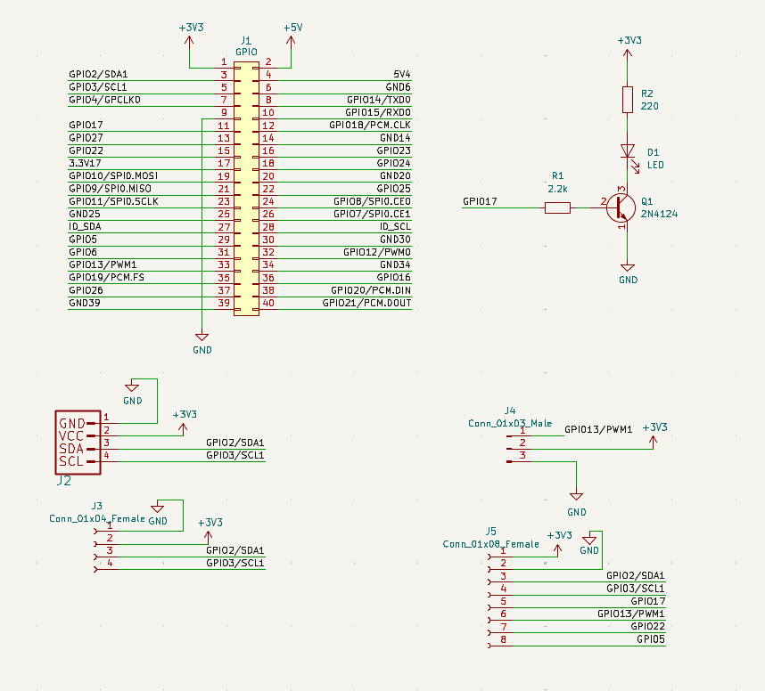
Appendix B: PCB Layout
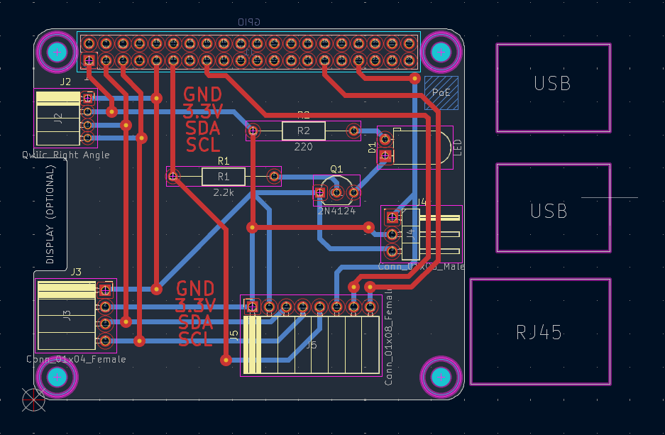
Appendix C: Firmware Source Code and PCB Design
Complete firmware code and PCB Design are included here
Appendix D: Datasheets
- VEML7700 Datasheet: Available at https://www.vishay.com/docs/84173/veml7700.pdf
- 2N3904 Datasheet: Available at https://www.onsemi.com/pub/Collateral/2N3903-D.PDF
- Raspberry Pi GPIO Pinout: Available at https://pinout.xyz/

